Kickstarter Projects Analysis

Trend Analysis Summary Of Successful Projects Based On Categories

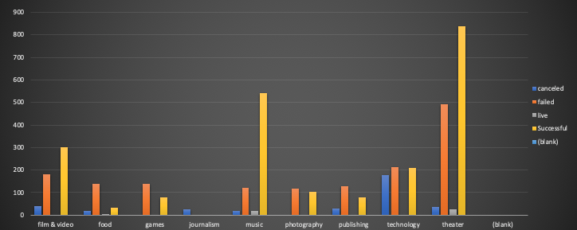

From the given data, our analysis shows that the maximum successful and failed projects have been in the Theatre Category with minimum failure seen in the photography projects. We see that the Food Category has been seeing maximum failure in comparison to the successful projects in the same and least Live number of projects which shows the funding in that category is not substantial.

Trend Analysis Summary For Project Success Rate Based On Sub -Category For Different Countries

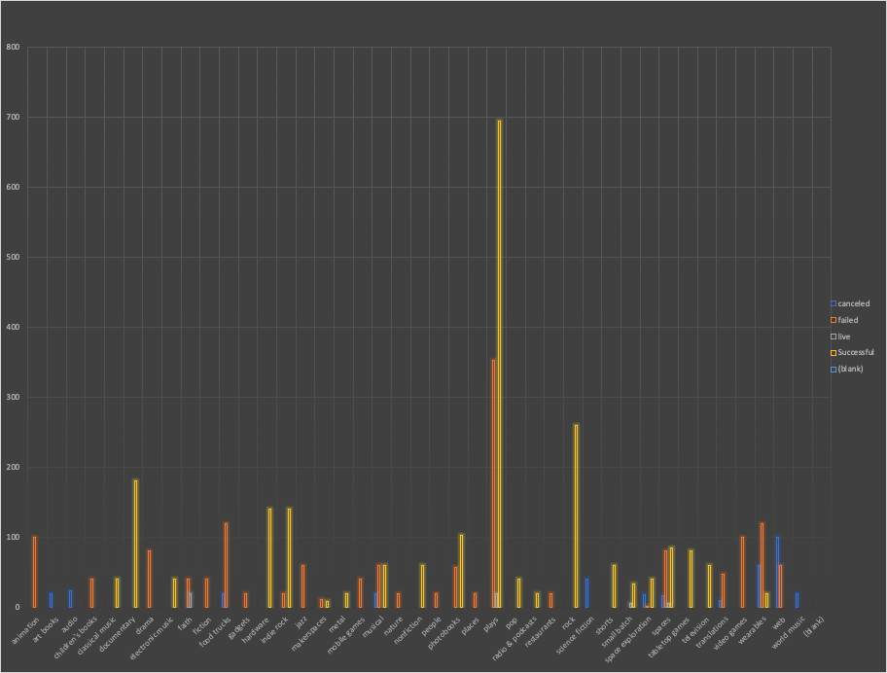

This analysis is filtered for each country and sub category of the projects provided in the data. For USA And GB, the maximum successful projects that got funded have been in Theatre Category specifically in Sub Category Plays. It is also significant to note that the maximum number of projects that got failed have also been in this sub category itself with NO Canceled Projects at all.

The Country IE whereas saw the maximum success rate in the Play sub category with 4 Total Projects , with only 1 Failed Project giving it by far the best project success rate.

Similarly for GB, the sub category Hardware saw the maximum number of successful projects with no Canceled or Failed projects making it a 100% success rate for any given category.

For the sub category Shorts, for all countries the success rate has been 100% with no Canceled or Failed Projects.

Trend Summary Of Project Success Rates Based On Time Of The Year

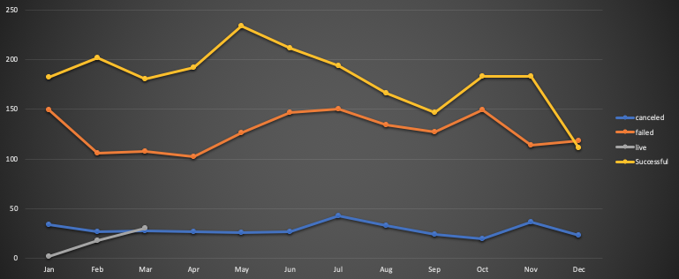

The graphical analysis depicts that any projects success peaks the highest during the Summer months specifically gaining momentum from April, reaching the peak in May.

The success rate dips really low in Fall subsequently resulting in projects failing & thus failure rates peaking in October - January. This could be an indication of maybe project resources are falling, people quitting, poorly planned budgets etc.

The Live projects are the highest during the Year's beginning Jan -Mar thus indicating funding & backer count being promising for projects when a new year starts.

We can also see that failure rate and cancellation rate trends have been similar during the summer months /mid of the year.

Trend Analysis Summary Of Project Success Rate Based On Goal Outcome

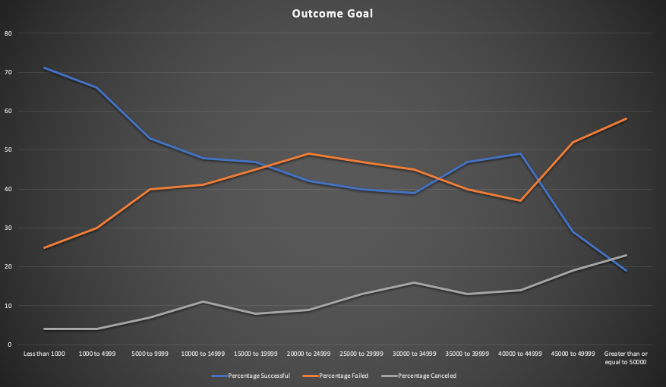

Outcome Goal graph trends suggests that the success rate of a given project is the maximum when the goal amount is <5000 which could indicate here that Low Budget Projects are considered less riskier for backers to fund the project.

Cancellation & Failure rates consistently keep going higher as the goal amount increases which could indicate lack of confidence on those projects to be funded by the backers.

As the failure rate increases for a bigger amount range of 45000-50000, the cancellation rate simultaneously increases.

Limitations

### Some limitations in this dataset identified are :

1. The fundraising timeline for the projects is fairly short.
2. The data set is gathered globally so the average donation for any project provided here is based on the country’s local currency which may have produced inaccurate donation amounts.
3. The data set also does not provide the actual individual average donations from backers in each subcategory.

### Suggestions

1. One data information that could have provided a better trend analysis is the failed and canceled projects information based on the direct correlation between the failed/canceled projects to lack of no. backers/average donations or resources.
2. The projects target audience is not defined and if surveys were included to understand the popularity of a project could give us better analysis ability on drawing more backers and donations.